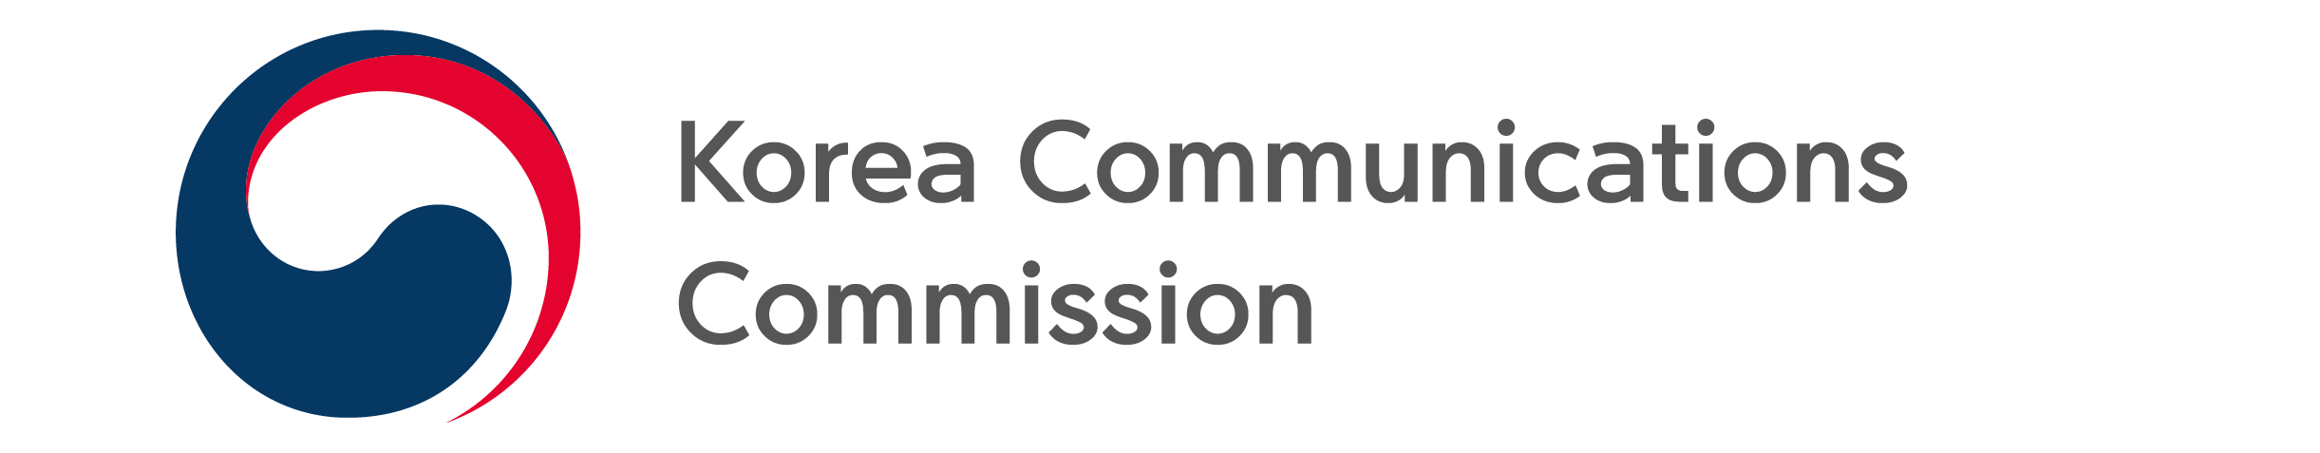
NEWS RELEASE
Date: Monday, February 20, 2023
Contact:
Media Diversity Policy Division (02-2110-1460, 1466)

Communications Dispute Mediation Committee mediated 82.9% of communications disputes in 2022

The resolution rate of 5G communications disputes increased significantly year on year (58.7%→81.9%)

The Korea Communications Commission (chairman Han Sang-hyuk) announced the result of communications disputes mediation in 2022 of the Communications Dispute Mediation Committee (chairman Kim Ki-joong). 1,060 communications disputes were applied and 835 cases were processed by the committee. 692 cases or 82.9% of them were mediated by agreement or acceptance.

In the wireless sector, KT had the highest number of applications for communication disputes with 316 (39.2%), and KT also had the highest number of applications per 100,000 subscribers with 1.8 cases. In the wired sector, KT had the largest number of applications with 106 (41.7%), while LG U+ and SK Broadband had the largest number of applications per 100,000 subscribers with 1.0 cases each.

By type (both wired and wireless) of applications, service contract takes up the biggest share (43.9%), followed by a notice of important information (40.2%), service quality (11.1%), and others (4.8%).

In addition, the number of applications for 5G communication disputes increased significantly from 245 in 2021 to 526 in 22, and the number of applications for communication service quality disputes decreased from 223 in 2021 to 118 in 2022.

The telecommunications dispute resolution rate (both wired and wireless) rose 7.3% points year-on-year from 75.6% in 2021 to 82.9% in 2022, 9.5% points (72.6%→82.9%) in the wireless sector, and 2.6% points (82.8%→85.4%) in the wired sector.

Meanwhile, the 5G (5 Generation) communication dispute resolution rate rose 23.2% points year-on-year from 58.7% in 2021 to 81.9% in 2022, and the communication service quality dispute resolution rate was similar from 53.4% in 2021 to 52.7% in 2022.

In the wireless sector, KT (85.6%) had the highest resolution rate, followed by LG Uplus (79.8%) and SKT (76.2%). In the wired sector, LG Uplus (87.5%) had the highest resolution rate, followed by SK Broadband (87.2%), KT (83.5%), and SKT (75.0%).

The Communications Dispute Mediation Committee will recommend the relevant operators for cases that hinder users' interests, such as false notification of device prices, forced use of high-priced plans, and omission of service termination to voluntarily solve the issues.

###
The Korea Communications Commission

