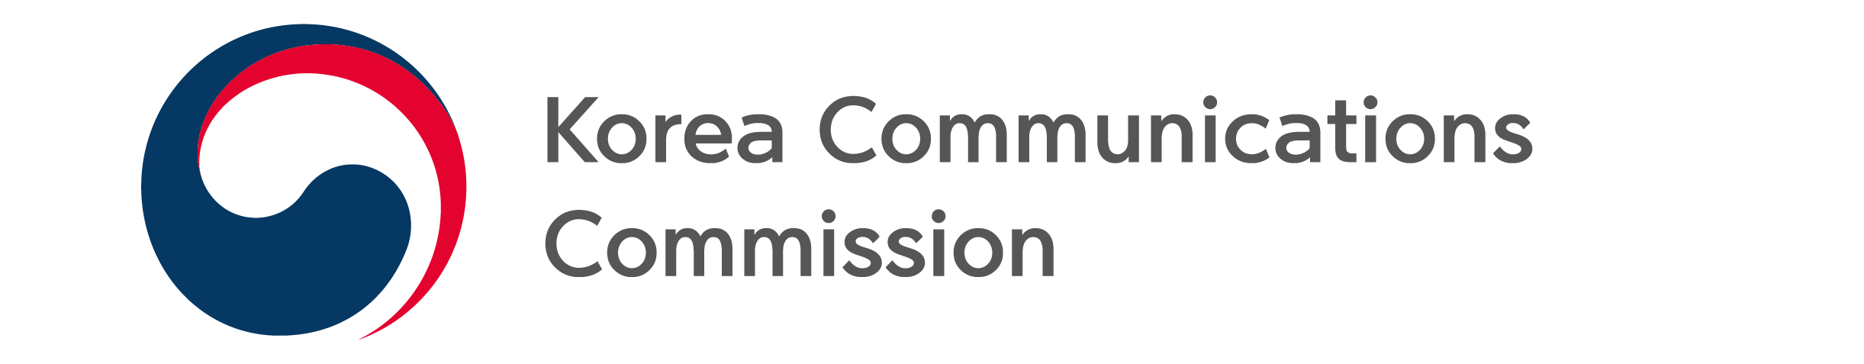
NEWS RELEASE
Date: Thursday, July 28, 2022
Contact:
Mobile Distribution Investigation Team (02-2110-1550, 1509)

COMPARE DOMESTIC/OVERSEAS MOBILE TERMINAL PRICES AT A GLANCE
Revamp website to provide more information about mobile devices by country

The Korea Communications Commission(KCC, Chairman Han Sang-hyuk) and the Korea Association for ICT Promotion(KAIT) announced that the ‘Domestic and Overseas Terminal Price Comparison Website (www.wiseuser.go.kr), which compares and analyzes the factory prices of domestic and foreign terminals will be revamped starting August 1.

The website, available since May 2018, provides information on prices of domestic and foreign major terminals in order to facilitate reducing the factory price of mobile communication terminals and encourage reasonable consumption by users.

The website was updated to make it easier to understand and use. In the past, users pointed out it was difficult to use the site as information on terminal prices were provided separately according to distribution channels such as mobile carriers, manufacturers, and open markets. Accordingly, the main terminal price information by country and distribution channel is now available in the form of a graph on the first page, and a menu has been created so users can easily compare and check domestic vs foreign prices at a glance.

The site also aims to help users understand the information they need by adding a function to automatically sort terminal price information by country and distribution channel.

Second, the site also provides additional information to help users when purchasing a terminal.
Now, the site also offers information on ‘subsidies’ by each mobile carrier as well as any ‘additional subsidies’ that are available; this information is expected to help users decide which terminal to purchase.

Additionally, a ‘feedback’ button will be added to the site to collect various opinions from users and better help users when purchasing a mobile terminal.

The site currently provides information such as prices and promotional products on 12 models, including Samsung Electronics and Apple's flagship terminals, with information on the top two mobile carriers, manufacturers and the number one open market in 17 countries including Korea. Through this information, it was seen that since 2019 the price of Samsung’s Galaxy S series in Korea has been relatively lower than that in other countries.

※ Korea's Galaxy S series terminal factory price ranking among 17 countries (higher ranking = lower price)
- (No. 1 mobile carrier) 5th (S10, ‘19. 6) → 5th (S20, ‘20. 6) → 3rd (S21, ‘21.6) → 2nd (S22, ‘22.6)
- (unlocked terminals) 5th (S10, ‘19. 6) → 4th (S20, ‘20. 6) → 2nd (S21, ‘21.6) → 1st (S22, ‘22.6

The KCC continues to received feedback on the terminal price comparison information and the website. Users can visit the portal site “Wiser User” (www.wiseuser.go.kr) to submit their opinions.

###
The Korea Communications Commission

