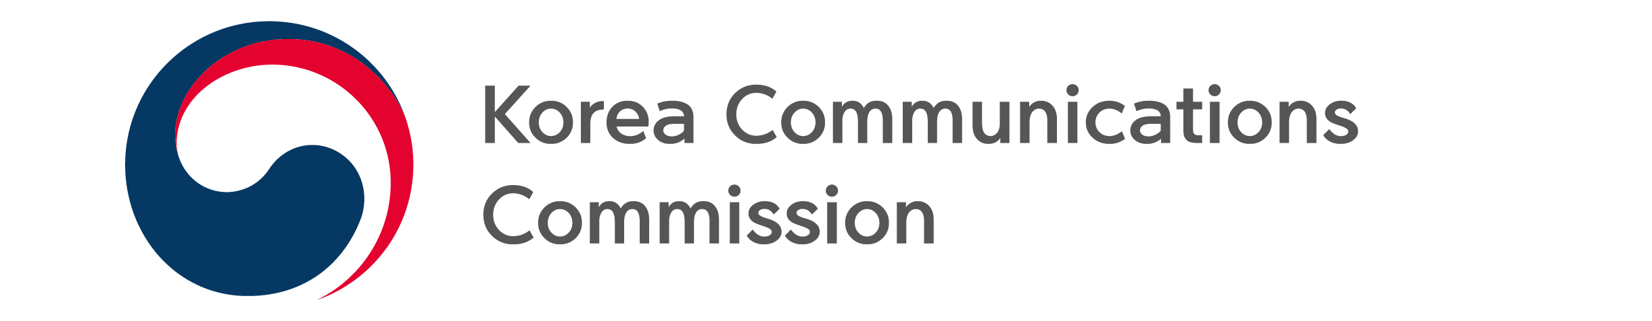
NEWS RELEASE
Date: Tuesday, June 7, 2022
Contact:
Broadcasting Advertisement Policy Division (02-2110-1270, 1274)

KCC OPENS SECOND CONTEST FOR INNOVATIVE SME BROADCAST ADVERTISING
- 17 companies to be selected through contest held from June 7 to 20 -

The Korea Communications Commission (KCC, Chairman Han Sang-hyuk) along with the Korea Broadcast Advertising Corporation (KOBACO) will hold the second round of the 2022 Contest for Broadcast Advertising Production Support, targeted at innovative SMEs.*

*Venture, Inno-Biz(technology innovation), Main-Biz (management innovation), Green-Biz(excellent green management), Green-certified SMEs and global IP startup, IP management certified firms, social enterprises, preliminary social enterprises, firms supported by Korea Agro-Fisheries & Food Trade Corporation (aT center), leading regional innovation firms, Green New Deal Promising Companies, Baby Unicorns, Innovative Product Designated Firms

During the second round, 12 firms for TV ads and 5 for radio will be selected for a total of 17 firms. For TV ads, support for up to 50% of production costs (maximum 45 million KRW), and for radio ads, up to 70% of production costs (maximum 3 million KRW) will be provided.

Additionally, systematic support will be provided for marketing overall in addition to production costs through consultation, including broadcast advertising production and transmission.

Since 2015, the KCC has supported broadcast advertisement costs for innovative SMEs that have excellent technology but experience difficulty due to being not well known or lacking sufficient marketing capabilities. Since then, companies like Market Curly and Jakomo have received support for broadcast advertisement costs through this initiative, laying the foundation for their growth.

This year, 47 innovative SMEs will receive a total of 1.44 billion KRW in production cost support for broadcast advertisements. During the first round contest in February, 19 firms for TV commercials and 11 for radio (total of 30) were selected and are currently producing advertisements.

The application period for the second round of the contest is from Tuesday, June 7 to Friday, June 20 at 16:00. Interested firms can apply at the website designated for supporting SME broadcast advertising (http://www.kobaco.co.kr/smad).

※ The application form, additional documents and other details can be found at the website, and the selection date may change according to the state of the application process.

###
The Korea Communications Commission

