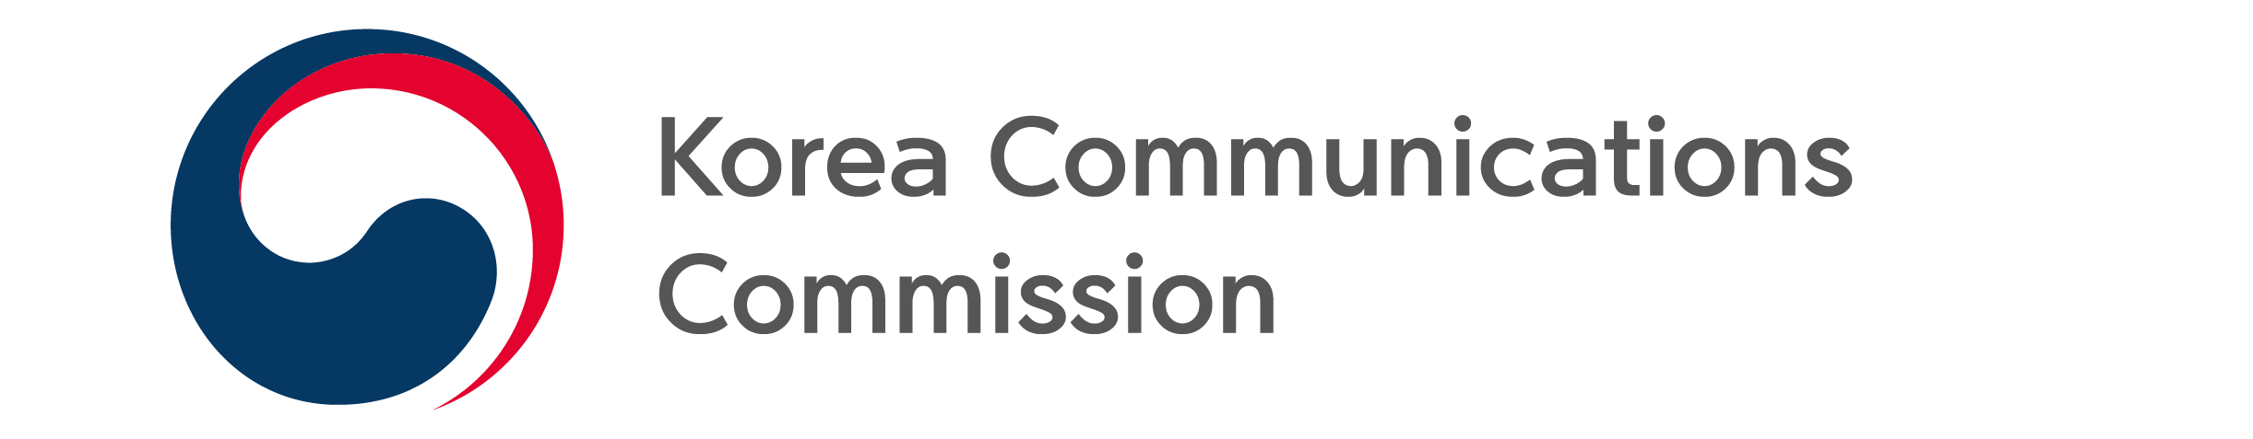
NEWS RELEASE
Date: Friday, June 24, 2022
Contact:
Consumer Protection Division (02-2110-1540, 1546)

STRENGTHEN USER RELIEF IN CASE OF DISRUPTION OF TELECOMMUNICATIONS SERVICES

- Standard time for compensation reduced from 3 to 2 hours, standard compensation amount is increased from 6 to 10 times
- Clarification of automatic refund without user application
- Easily search and claim damages for communications service disruption through website and app

Amidst the frequent cases of telecommunications service disruption, and the resulting interest in user relief and compensation from harm, the Korea Communications Commission (KCC, Chairman Han Sang-hyuk) recently announced that it will require improvements to the Terms of Use of major telecommunication companies (SKT, SKB ·KT · LGU+).
The key points of the required improvements for compensation and relief are as follows.
First, the standard time for compensation is decreased and the amount is increased. If the provision of high-speed Internet and mobile phone services is interrupted for more than two consecutive hours, users can claim compensation for 10 times the fee for the duration of service interruption.
This decision follows comprehensive consideration of various factors including the sophistication of communication networks, the introduction of smartphones and changes in communication service usage, as well as the recovery time needed when there is communication services disruption, consistency with the regulations of the Telecommunications Business Act*, and domestic and foreign cases. In addition, the standard amount has been greatly expanded so that a wide range of compensation can be made for user damage caused by interruption of communication service provision.
Second, if the communication service is interrupted, the refund is automatically returned to the user in the following month without requiring a separate application. Unlike compensation for damages, for which the user must apply directly, the fee refund will return (or reduce or exempt) a prorated amount of the monthly subscription fee according to the number of days of service interruption without the user's separate application. Because there is an unclear aspect to the policy, the Terms of Use will specify that the amount will “be automatically returned next month.”
Third, requirements for providing information on the interruption of communication services and compensation for damages on the website and customer center app of the telecommunication company will be strengthened. Currently, in the event of a telecommunication service interruption, it is not easy to find information about service interruption on the telecommunication company’s website or customer center app, and there is no guidance on the procedure or form for claiming damages. Accordingly, a separate menu will be created on the website and customer center app so that users can quickly and easily identify and respond to communication service interruptions.
Regarding revision of the Terms of Use, the KCC announced that major telecommunication companies will go through the reporting procedure with the Ministry of Science and ICT, and improve and implement the computer systems in July. Reorganization of the website will be carried out in August.

###
The Korea Communications Commission

