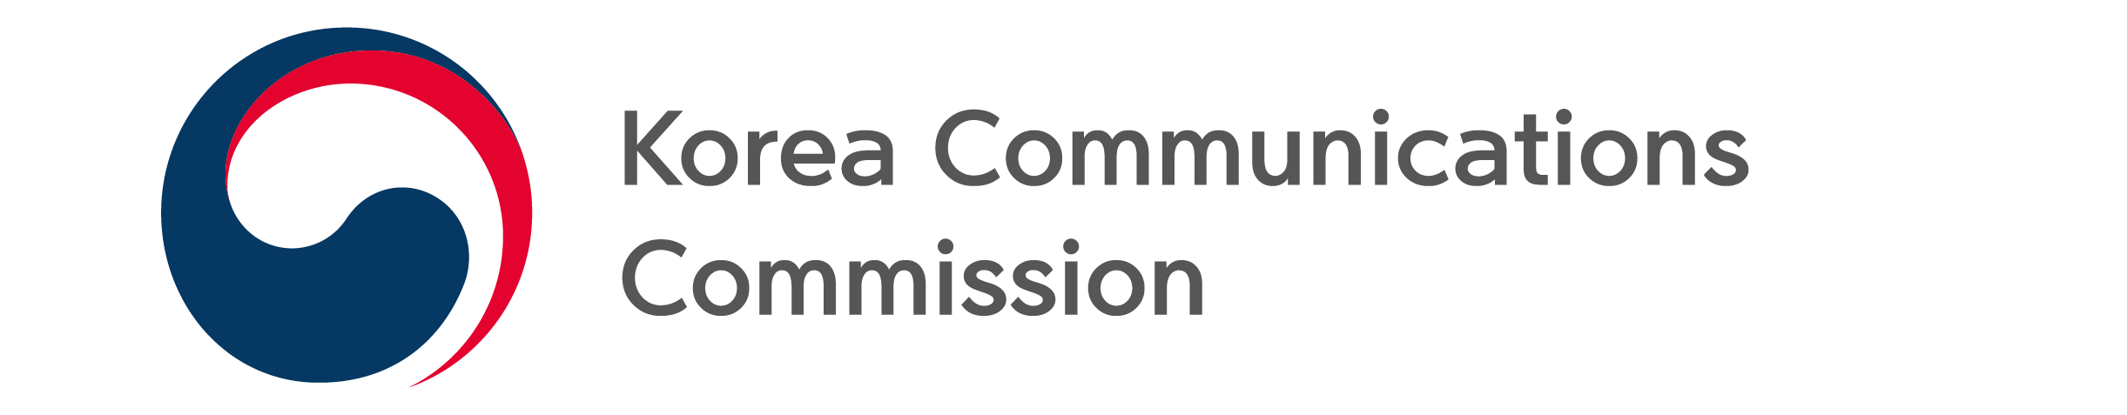
NEWS RELEASE
Date: Friday, November 25, 2022
Contact:
Broadcast Advertising Policy Division (02-2110-1270, 1274)

KCC HOSTS ‘2022 KOREA PUBLIC SERVICE ADVERTISING FESTIVAL’

Covers topic of the “reality” of hardships that digitally vulnerable citizens face
Online exhibition of the winning production, other domestic and overseas PSAs

On November 25, The Korea Communications Commission (KCC, Chairman Han Sang-hyuk) held the ‘2022 Korea Public Service Advertising Festival’ at the Korea Advertising Culture Center with the Korea Broadcasting Advertising Promotion Corporation (President Lee Baek Man).

The Korea Public Service Advertising Festival was launched in 2009 to form public consensus on social issues and raise awareness and action through public service ad contests; this year marks its 14th anniversary.

This year's Public Service Advertising Contest Awards Ceremony was the first since 2019, due to the pandemic, where winners, broadcasters, and broadcasting professionals could gather together in person to congratulate each other. It was also broadcast live online through the 'Public Service Advertising Council' YouTube channel.

A total of 1,204 entries were submitted in the TV, print, video, and emoticon categories, which were divided into general, college student and youth divisions. Of the applicants, 29 finalists were selected through preliminary and final evaluations.

###
The Korea Communications Commission

