NEWS RELEASE
Date: Friday, January 20, 2023
Contact:
Media Diversity Policy Division (02-2110-1460, 1466)

Now Spam Report Available in the App

Streamline the report of spam text messages and phone calls, even available on foreign phones

Korea Communications Commission (KCC, chairman Han Sang-Hyuk) and Korea Internet Security Agency (KISA, chairman Lee Won-Tae) announced the application for simple reporting of mobile phone spam to solve user inconvenience in reporting spam.

It has been possible to use the feature of reporting spam in phones to report spam messages. However, the feature was only available on Samsung devices and unavailable on foreign devices such as iPhones.

In addition, as the feature of reporting spam phone calls was only available in Samsung’s latest devices, there was the need for the additional measure to block spam phone calls.

To solve the inconvenience, KCC and KISA developed the app for simple reporting of mobile phone spam. A user can easily report spam and see the result after one-time authentication.

In the case of Android phones, you can choose the number you want to report on recents calls and messages report them maximum five numbers at once. In the case of foreign phones such as iPhone, you can take a screenshot and submit the image.

The application is available on three app market places (Google Play, Apple App Store, and ONE store), and for more information visit KCC and KISA blogs and spam.kisa.or.kr.

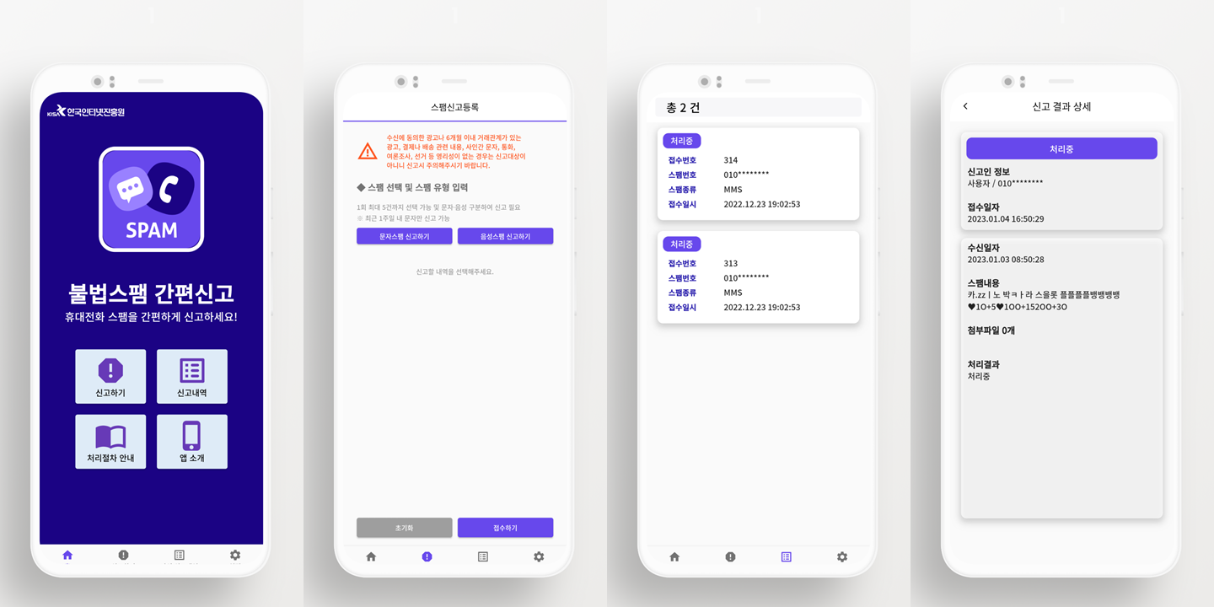
“As spam messages are used for voice phishing, we need to report and block them promptly,” KCC chairman Han Sang-Hyuk said. He adds “ahead of the Lunar New Year holiday, its strategies and tactics are getting more sophisticated, so the app will be helpful to prevent the damage.”

###
The Korea Communications Commission

